***UT Bathroom Services***

Technical Documentation

Last Updated: Dec 4, 2017

***Authors:*** David Chun, Zoe Ng, Joel Wang, Hans Xu

***Source Code:*** <https://github.com/dChunGit/UT-Bathroom-Services>

***Overview:***

The UT Bathroom Services (UTBS) app was created to help people locate quality restrooms and water fountains around campus. Our solution creates a central database populated by user reviews which enable us to provide quantifiable data to the consumer. Locations (Bathrooms or Water Fountains) are each ranked by proximity, cleanliness, user reviews, and other criteria including wifi quality, taste, or temperature. Users are able to view and filter available locations, add new reviews/locations, as well as tag their favorite places. The UTBS app will be the one-stop shop for users to find information about bathroom and water fountains on the UT campus.

***Problem:***

Everyone needs to use the restroom or refill their water bottle multiple times during the course of a day on the UT campus. When people find themselves in an area of campus in which they are unfamiliar and need to use the facilities, it can be hard to locate them without guidance. The time used to wander around a building looking for the facilities could have been used to study for tests or do homework, and students may not have the time to search for a bathroom, especially when walking to their next class. On the other hand, when people are not in a rush to get to their next class and have plenty of time, they may want to locate the restroom with the best Wifi or the least amount of noise so they can do their business in peace. Unfortunately. students will need to locate and use every single one on campus to determine the best restrooms at UT, which takes a sizable amount of time and effort that could be put towards studying.

Additionally, when a student needs to fill their water bottle, it can be hard to locate a water fountain or refill stations on campus. Some water bottle refill stations do not allow easy access for large containers or may produce warm water, which is not desirable in the hot Texas weather. As a result, some students or faculty members may resort to buying water bottles from the convenience store or vending machine, and this is an expensive choice in the long run with negative environmental impacts.

Our solution, an Android app, displays the location of bathrooms and water fountains on campus and provides ratings on the facilities that allow everyone at UT to easily locate facilities and get relief.

***Specifications:***

Minimum Android Version: 19 (KitKat)

Compile SDK Version: 27 (Oreo)

Permissions: ACCESS_FINE_LOCATION

Tested Platforms: 23 (Marshmallow), 24/25 (Nougat), 26 (Oreo)

***Application Structure:***

In this section, we will give a short explanation of the high level components and characteristics of the application while briefly discussing how each thread connects to others through their corresponding callbacks.

*Activities*: The main display controllers

* **SplashScreen**: Shows a loading screen while initializing Google Play Services.
* **Database**: Used for temporary data storage, specifically during configuration changes but can also be used for caching/storing the data.
* **MainActivity**: Shows tutorial if the app is running for the first time, sets up all the fragments to query the Firebase database and the location database, starts location updates. Controls the main view of the application including the map, markers for each location, map controls, and review data display.
* **Add**: Interface for adding a new review or a new location for either Bathrooms or Water Fountains. Handles user ratings and pushes to the Firebase database
* **Favorites**: Displays the user’s list of marked favorites.
* **Reviews**: Displays a list of reviews the user has submitted to the UTBS database.
* **Search**: Allows the user to search through the ratings/reviews for both Bathrooms and Water Fountains to find one matching their standards.
* **About**: Contains quick information about the application, links to source code, libraries and their licenses, as well as a changelog.

*Fragments*: Secondary controllers not bound to an activity context

* **LocationFragment**: Binds and starts the location update service defined in the manifest and as LocationService. Using the *UpdateLocationListener* callback and the *LocationCallback* interface, this fragment receives regular, timed updates from the location service and sends it back to MainActivity to update map location. Retained across configuration change via the fragment manager.
* **UpdateFragment**: Starts a database query based on the parameters sent during initialization of the fragment. Receives database updates via the *DatabaseCallback* callback and sends the information to MainActivity through the *onUpdateListener* interface. Retained across configuration change via the fragment manager.
* **SearchFragment**: Starts an AsyncTask to search through all the ratings, filtering only ones matching sent parameters. The *SearchCallback* interface allows this fragment to communicate with MainActivity, sending back the search results to process the markers displayed on the map. Retained across configuration change via the fragment manager.
* **AboutFragment**: Populates the adapters for the layouts in the About activity, setting up all listeners and views to properly display the data.

*Services*: Runs in a background thread away from the main UI thread

* **LocationService**: Starts GoogleLocationServices to query using the Google location api as a service, delivering new location data on an interval. Location data is sent from the *LocationRequest* callback to LocationService via the *LocationUpdateListener* interface and sent back to MainActivity using the *LocationCallback* interface. Using a service allows for persistent, asynchronous updates.

*Firebase*: Stores location and review data for each bathroom/fountain in a cloud database

* **Bathroom**: Holds all the fields for a Bathroom location. Includes all the individual Ratings corresponding to the Bathroom location.
* **WaterFountain**: Holds all the fields for a Water Fountain location. Includes all the individual Ratings for the Water Fountain.
* **Rating**: Holds a single Rating for either Bathroom or a WaterFountain, including all the rated parameters and any comments attached to the review.
* **Building**: Holds a list of all the buildings currently belonging to UT according to <https://facilitiesservices.utexas.edu/buildings/>. Implemented here in the app to allow for updates if building information changes.

*Database*: DBFlow SQL database to store reviews and favorite locations

* **AppDatabase**: Holds the name and version for the SQL database of DBFlow
* **Favorite_Item**: Holds key identification elements for the current user’s list of marked favorite Bathrooms/WaterFountains.
* **Rating_Item**: Holds a local reference to a rating submitted by the current user relative to the received ratings from the Firebase database.

*Other*:

* **SearchParams**: Holds search parameters used to send data to the SearchFragment.

***Features:***

There are multiple features in the UTBS app that help to provide the users the best experience possible. The search function allows users to search for facilities based on the qualities they desire, such as cleanliness and WiFi quality in the case of bathrooms and water temperature and if it is a bottle refill station in the case of water fountains. This narrows down the number of bathrooms or water fountains shown to the users, making the choice for them easier.

The Favorites page lets users to store their favorite bathrooms and water fountains that they have encountered on the UT campus, allowing to easily locate them again on the map and view others’ reviews on the facility. The Reviews page allows users to view the reviews that they have previously written for various bathrooms and water fountains. If a user wishes to edit their review on a facility due to changes in quality, the user can quickly access their reviews from this page.

***Example Use Cases:***

One usage scenario is when a student is walking from one class to another with only 10 or 15 minutes between classes. In this short amount of time, the student will not have much time to both locate a restroom or water fountain and get to class promptly. If they do choose to look for one, they may end up late to their class and possibly miss out on homework turn-in or lose time on an exam. With our app, this scenario is greatly alleviated. Students can open up the app on their phone, and based on their current location, the app will display the nearest bathrooms, allowing them to quickly locate a bathroom and take care of their business in time for class.

Another usage scenario is when a student has plenty of time until their next class and wants to refill their water bottle with the coldest water available. The student can use the app to search feature to filter water fountains based on water temperature, and the app will display the locations of these water fountains on the map. Then, the student can walk to one of the water fountains and refill their water bottle with refreshing, cold water, and be on their way to their next class.

***Screenshots:***

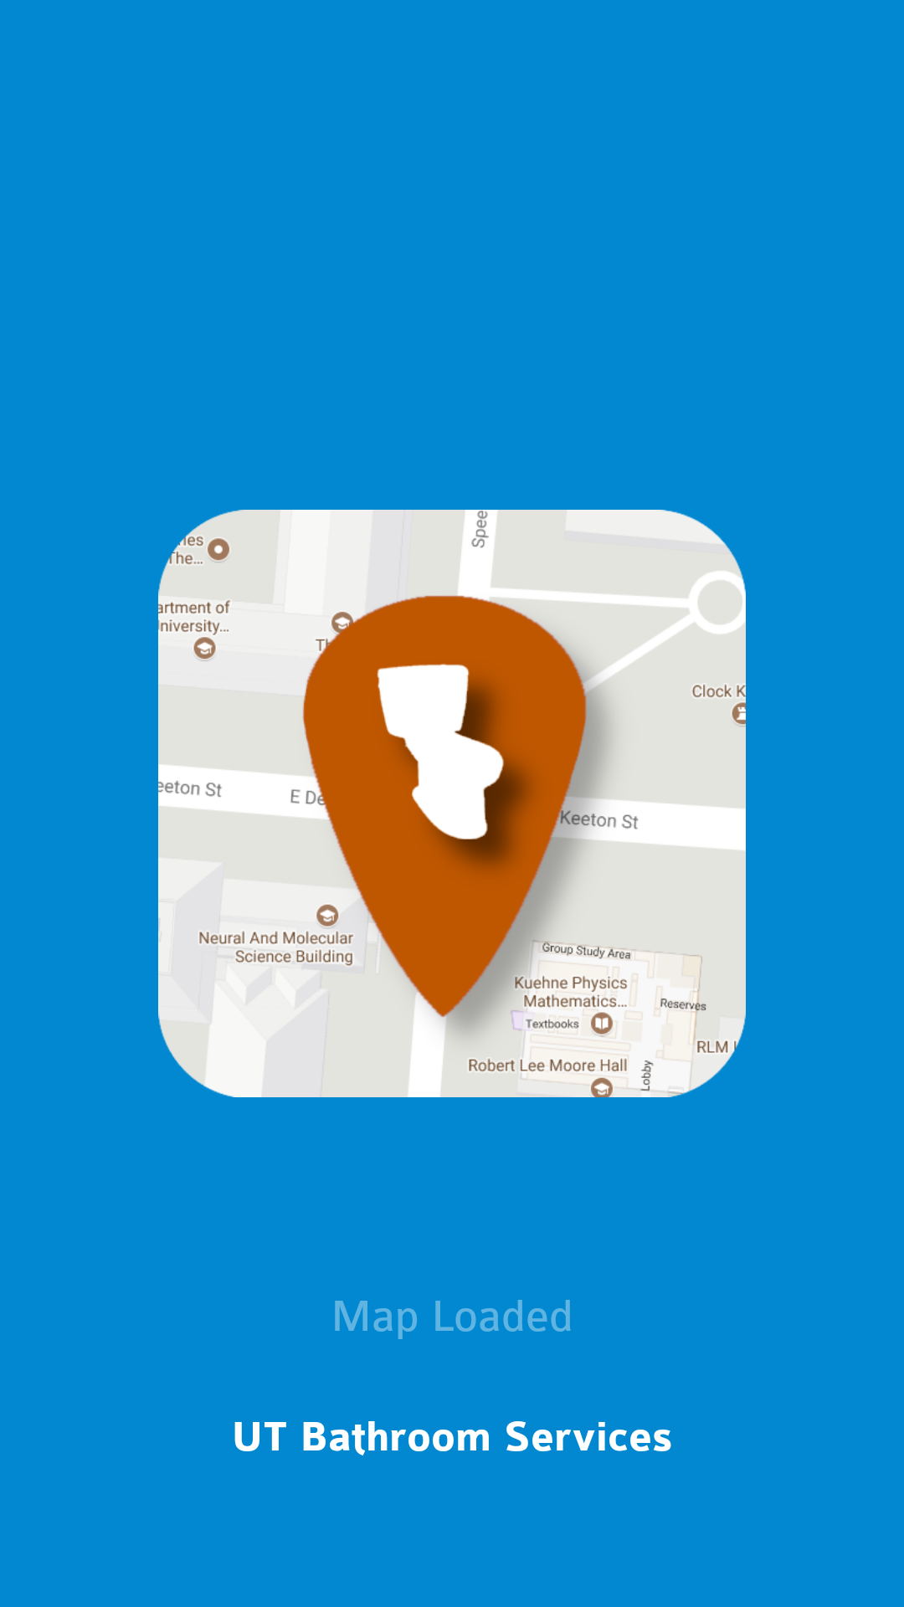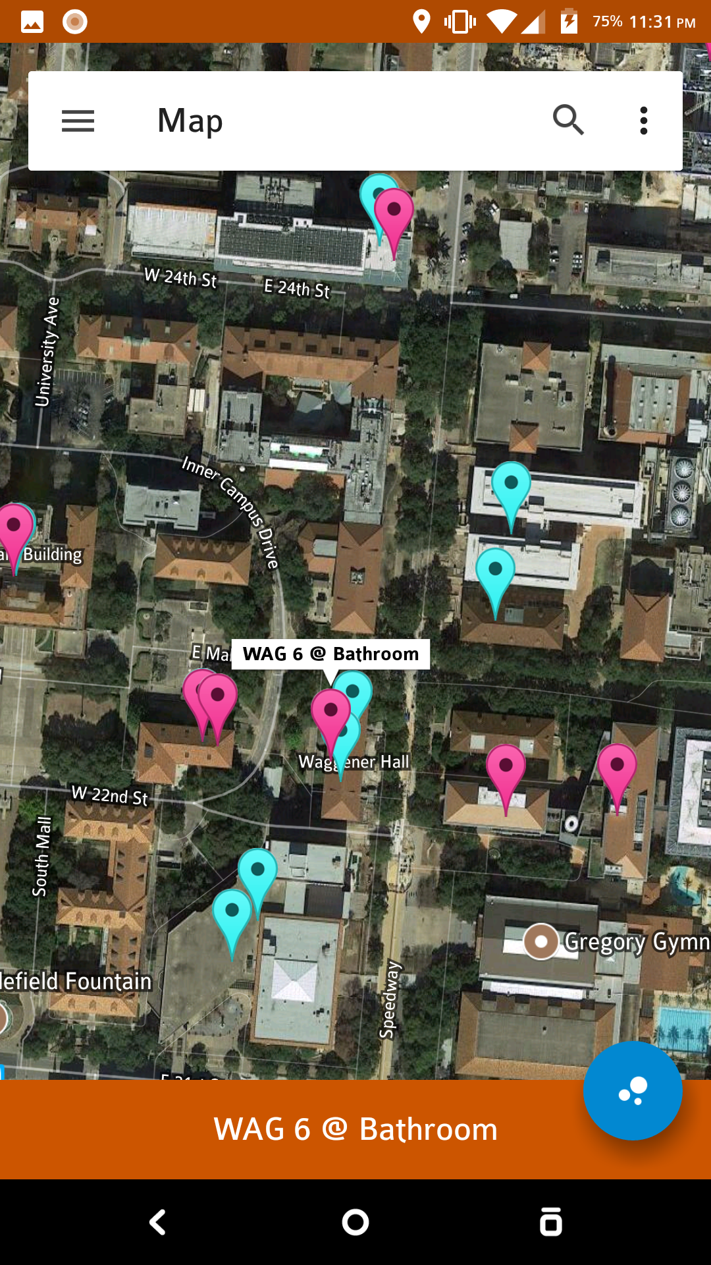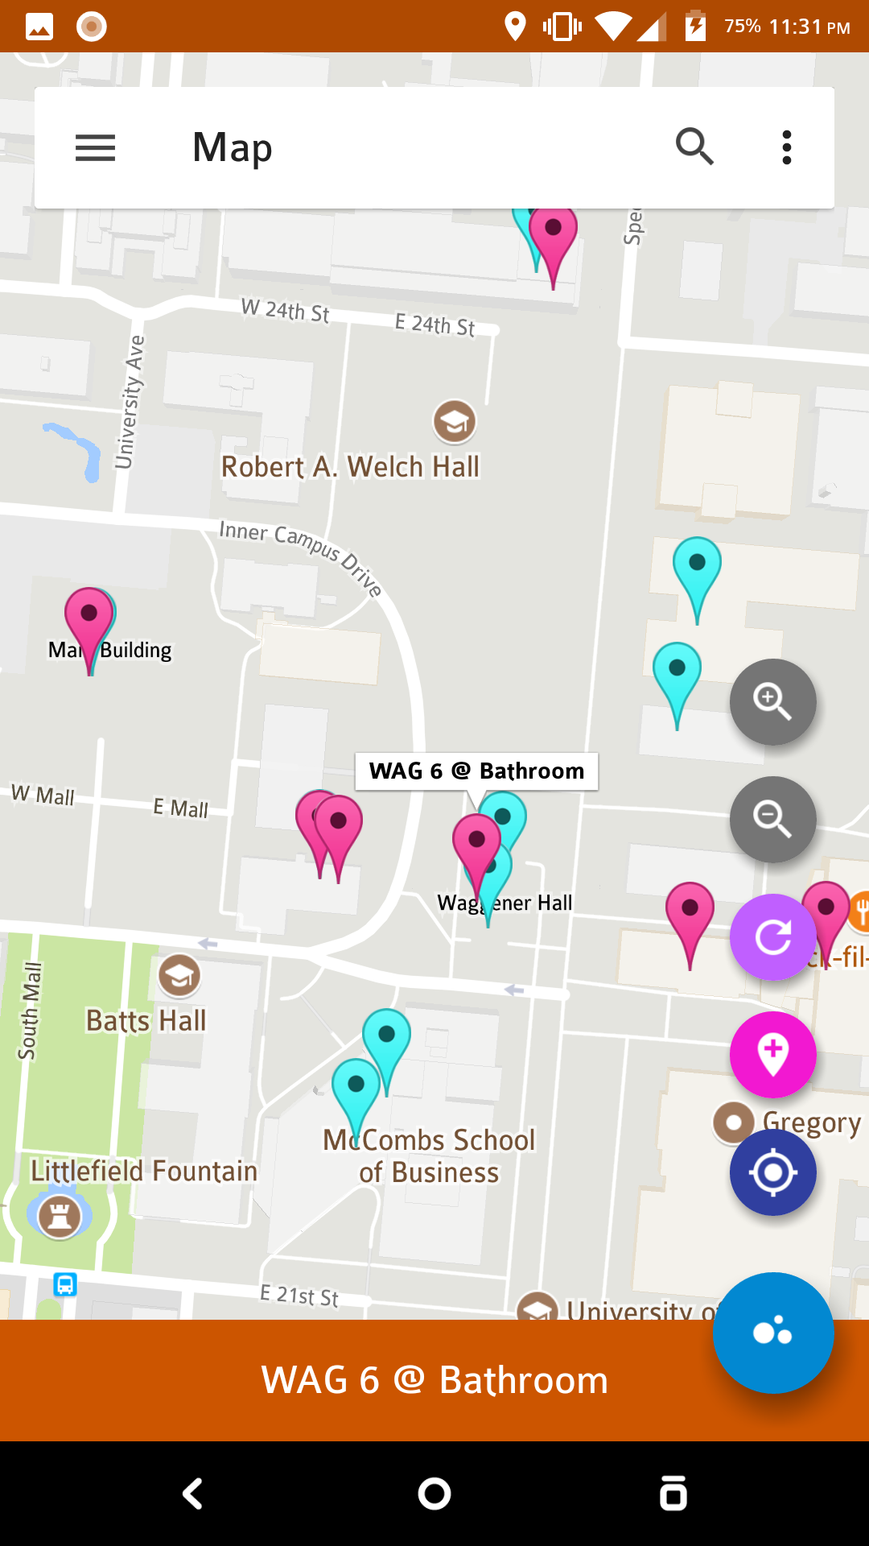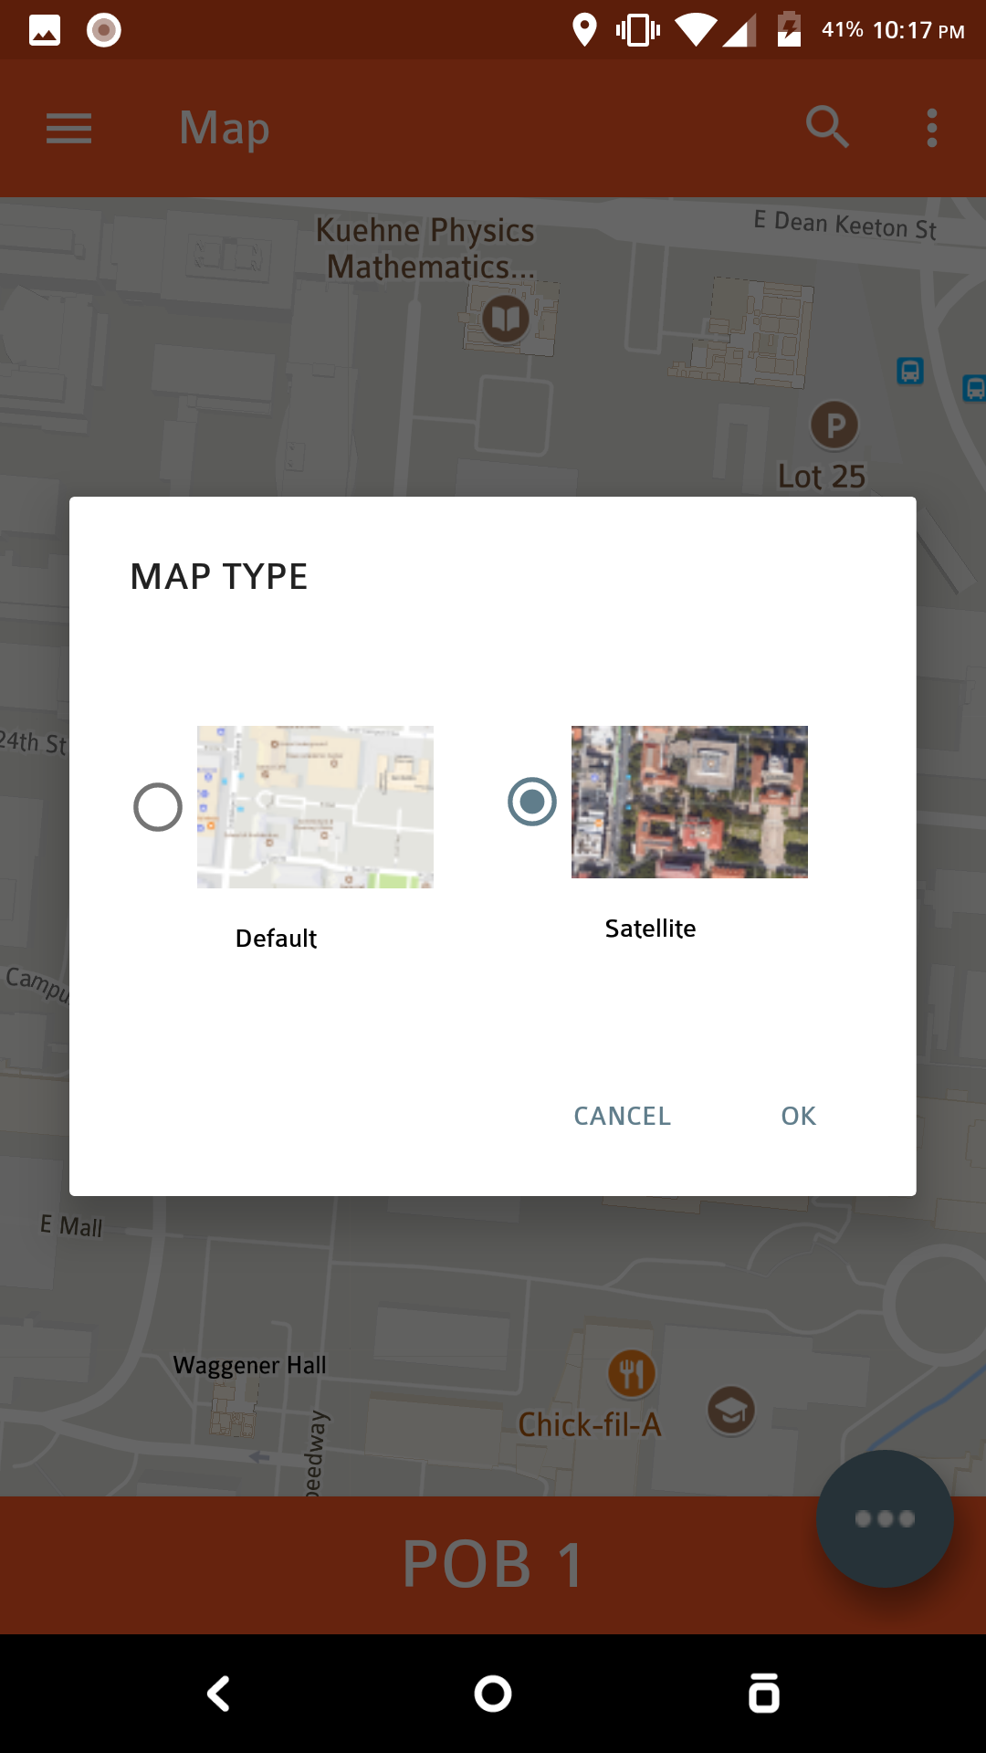

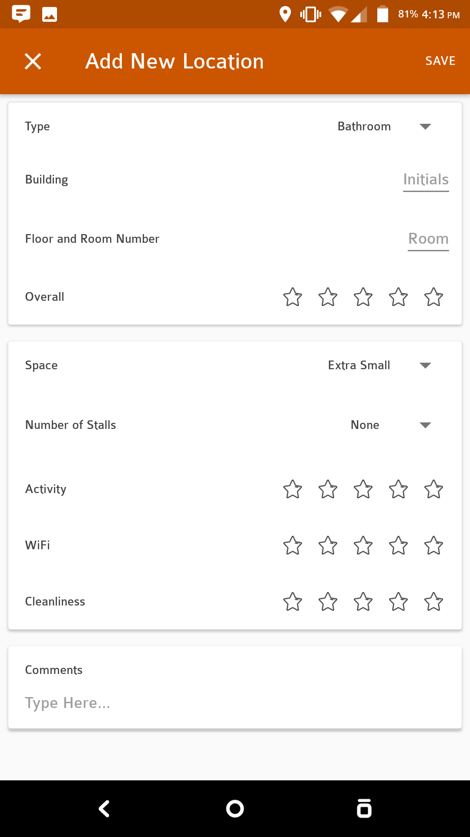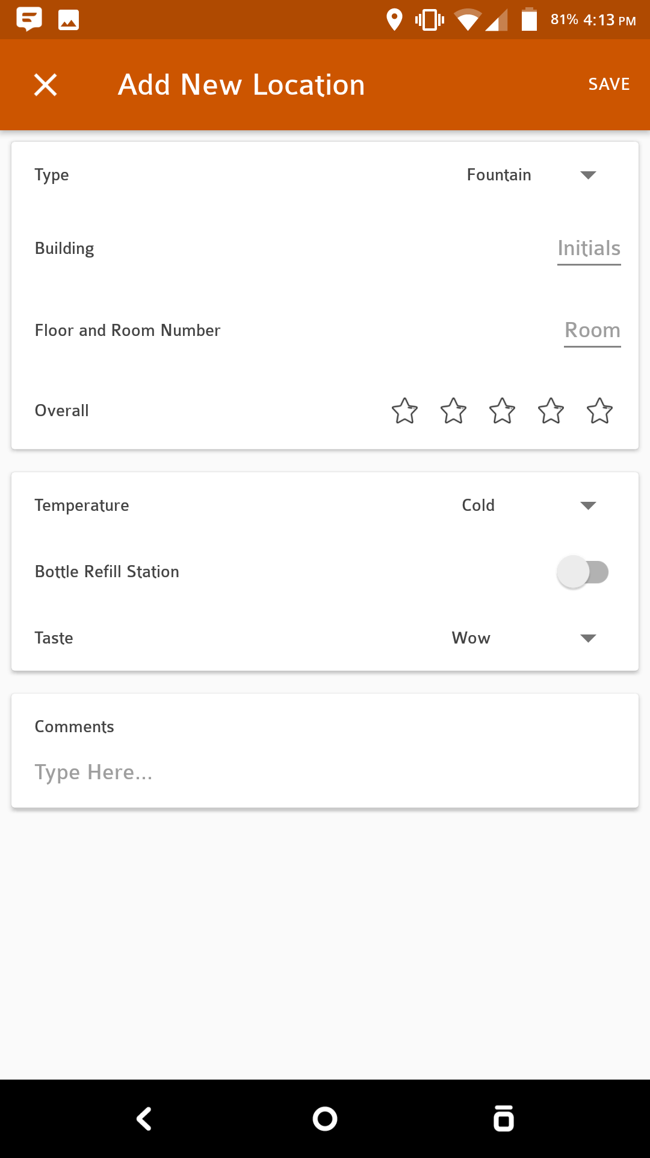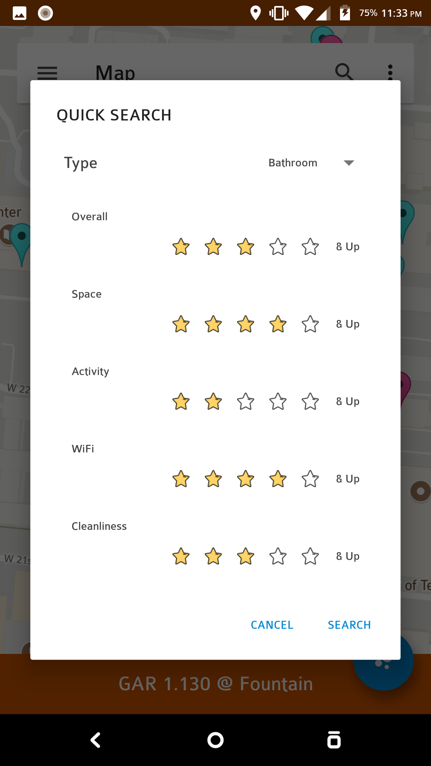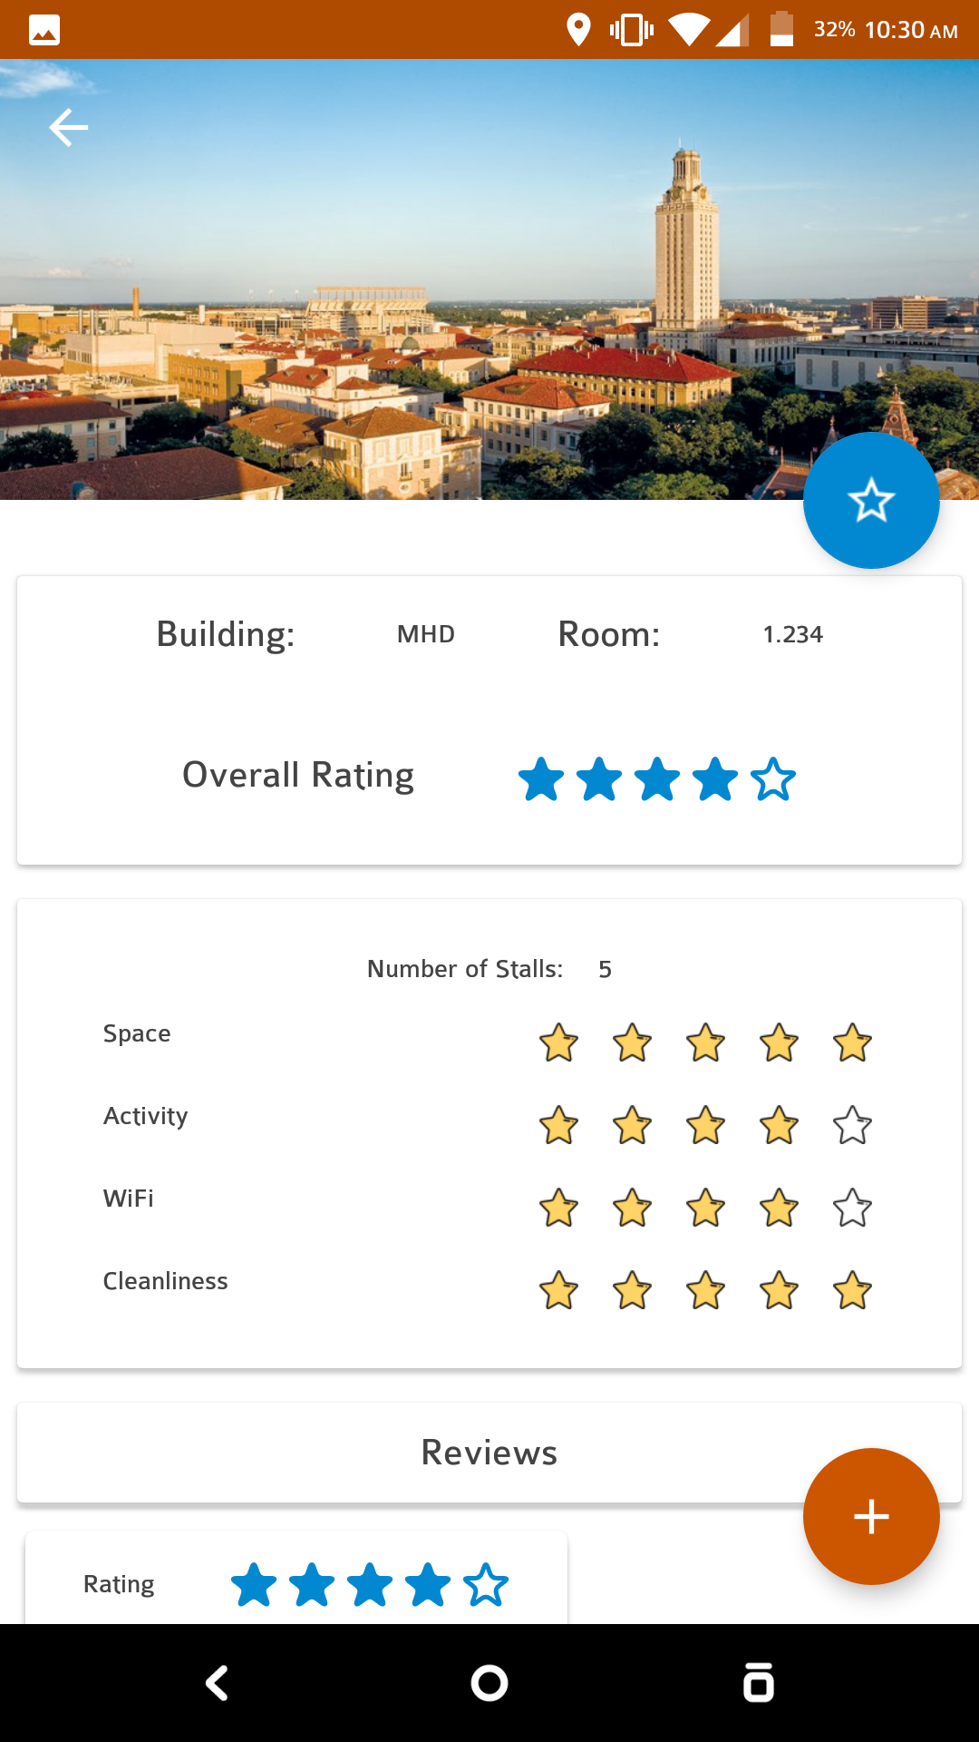

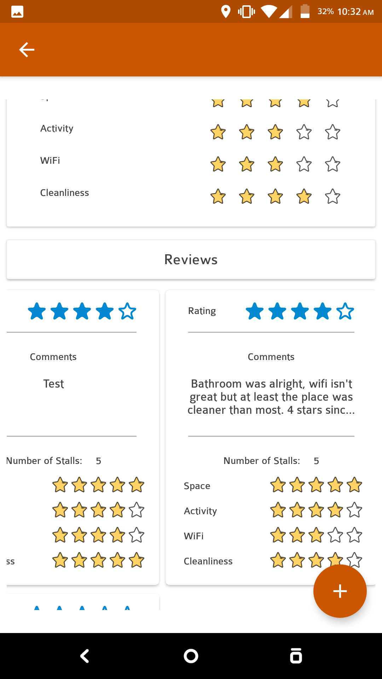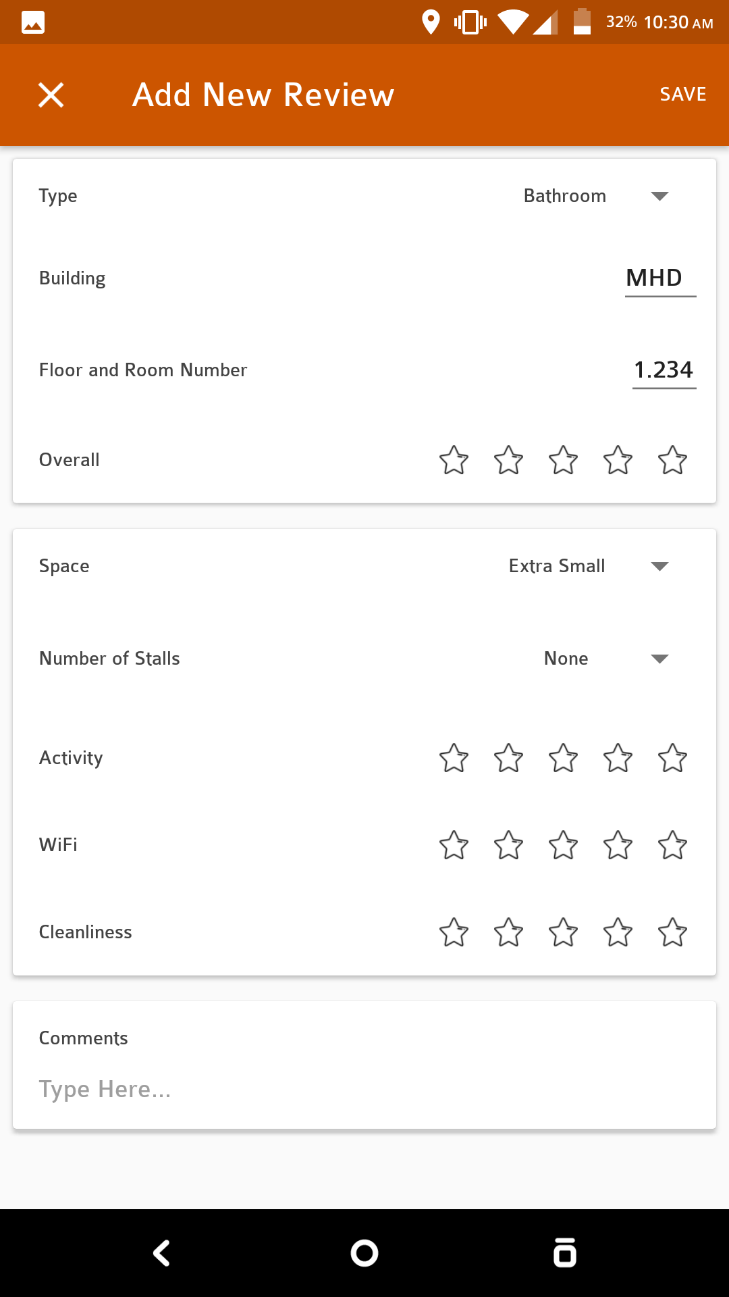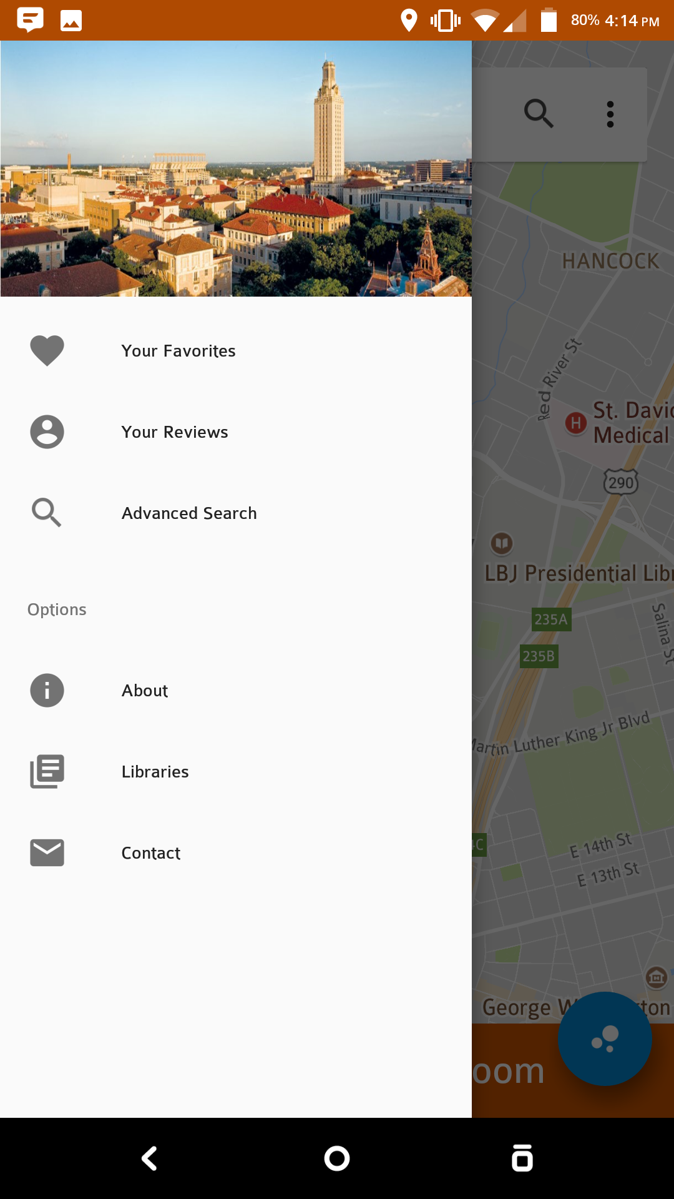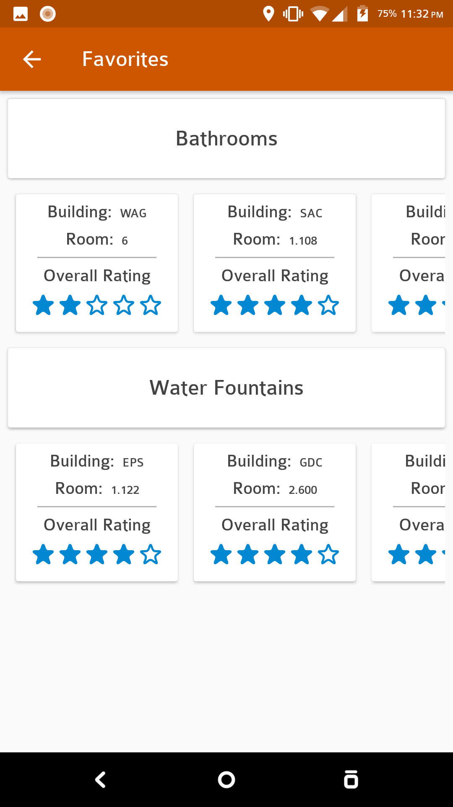

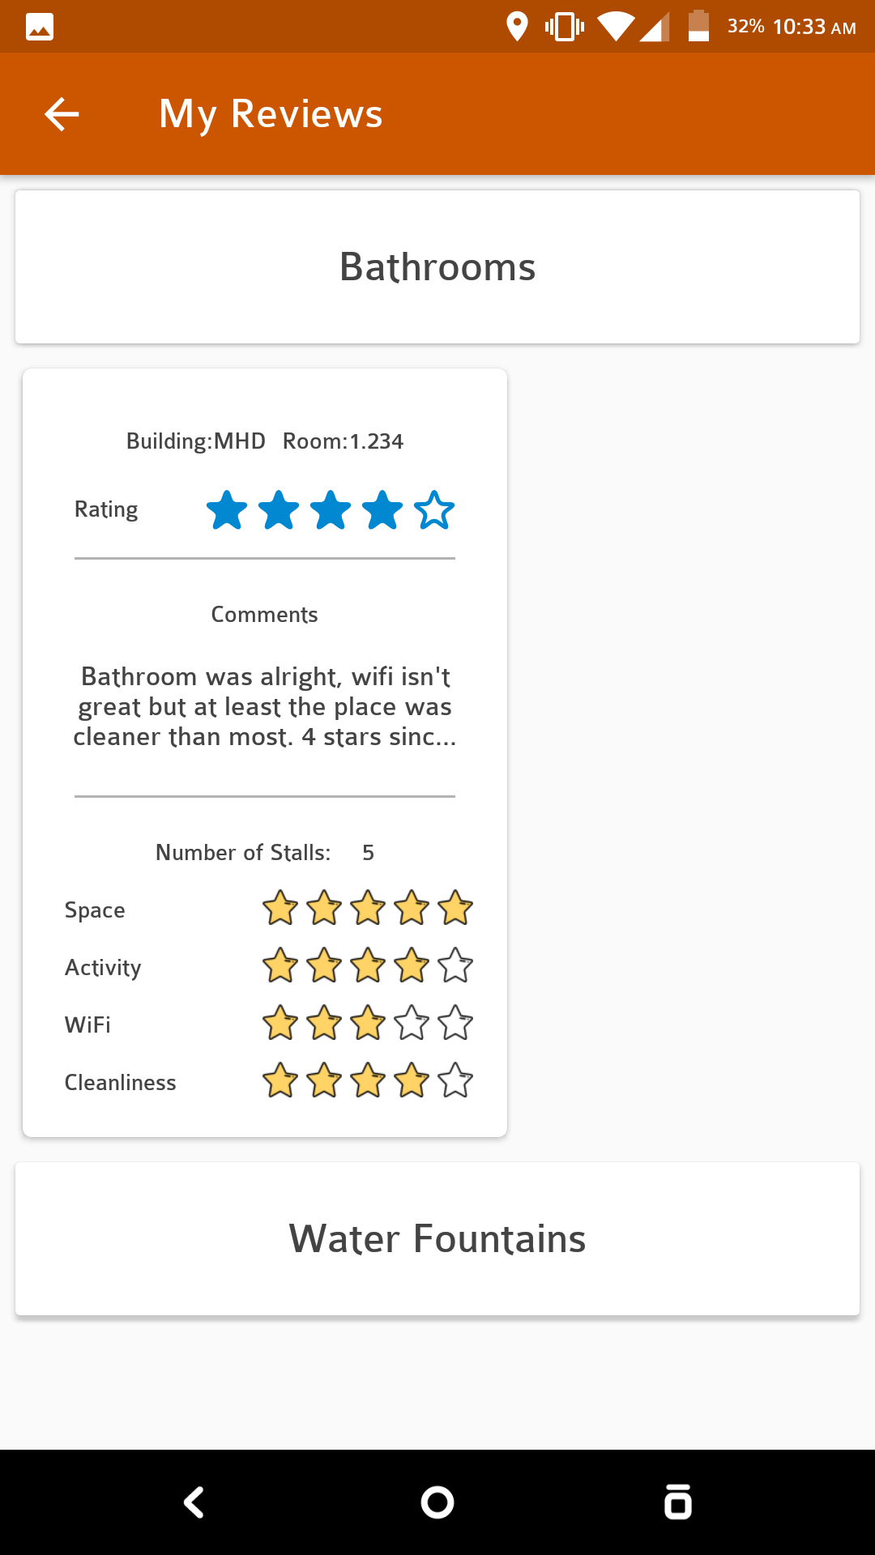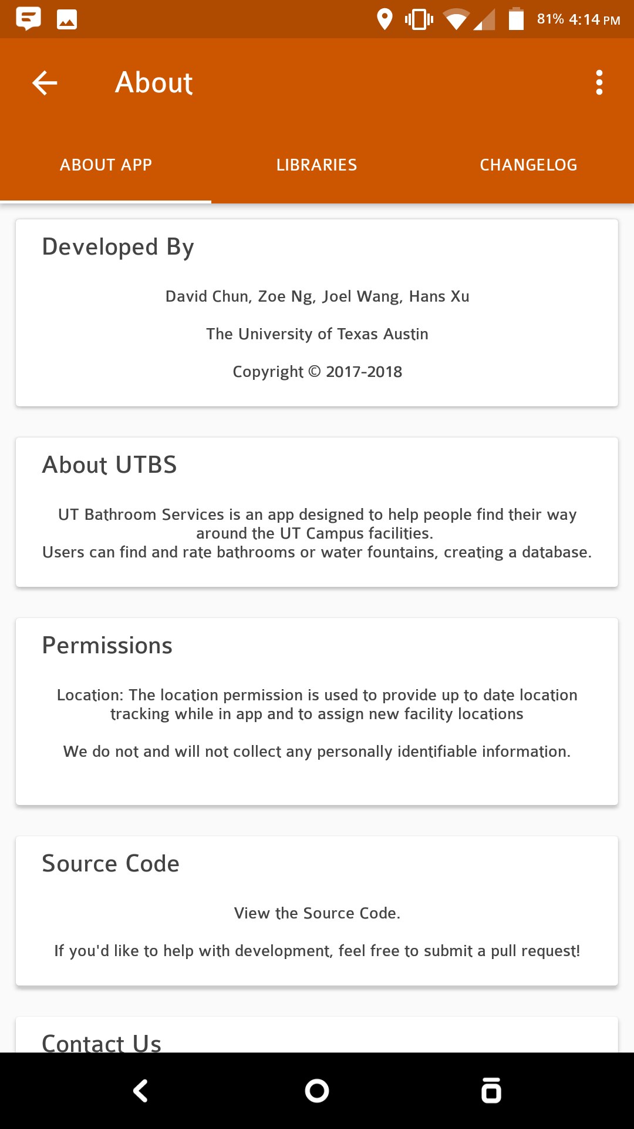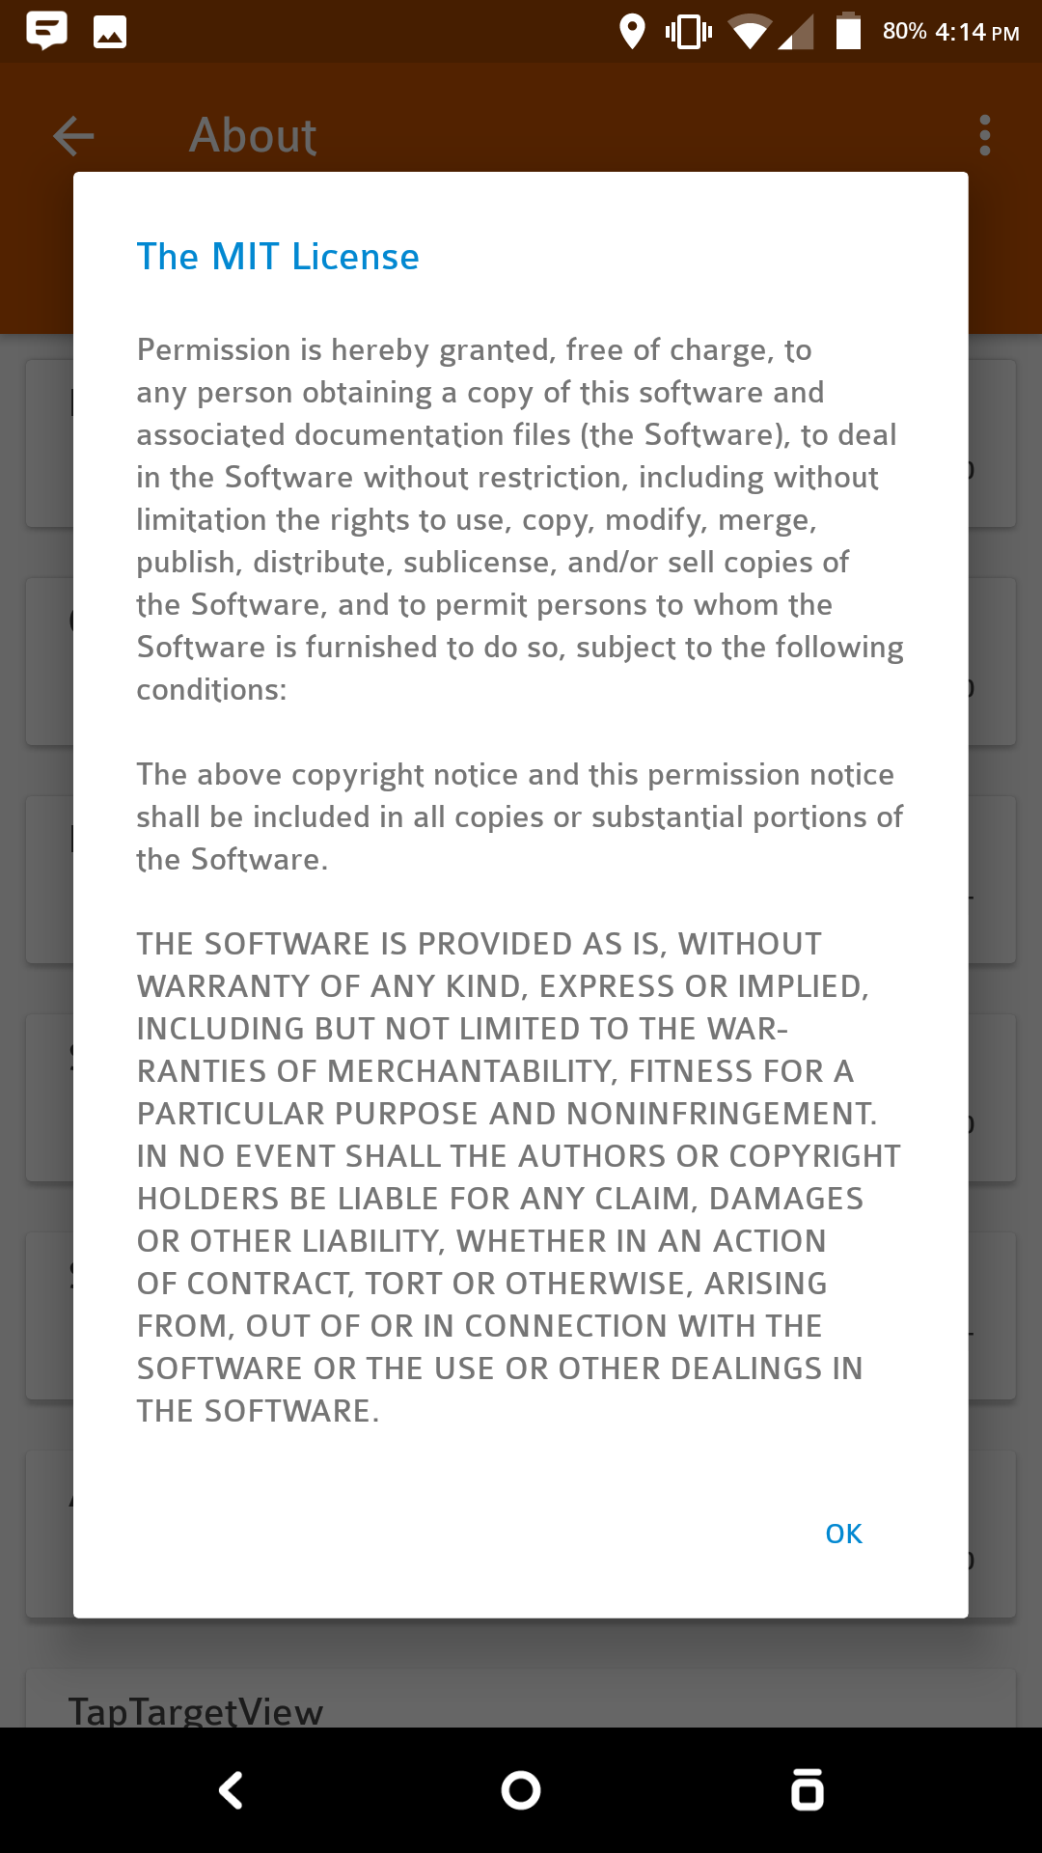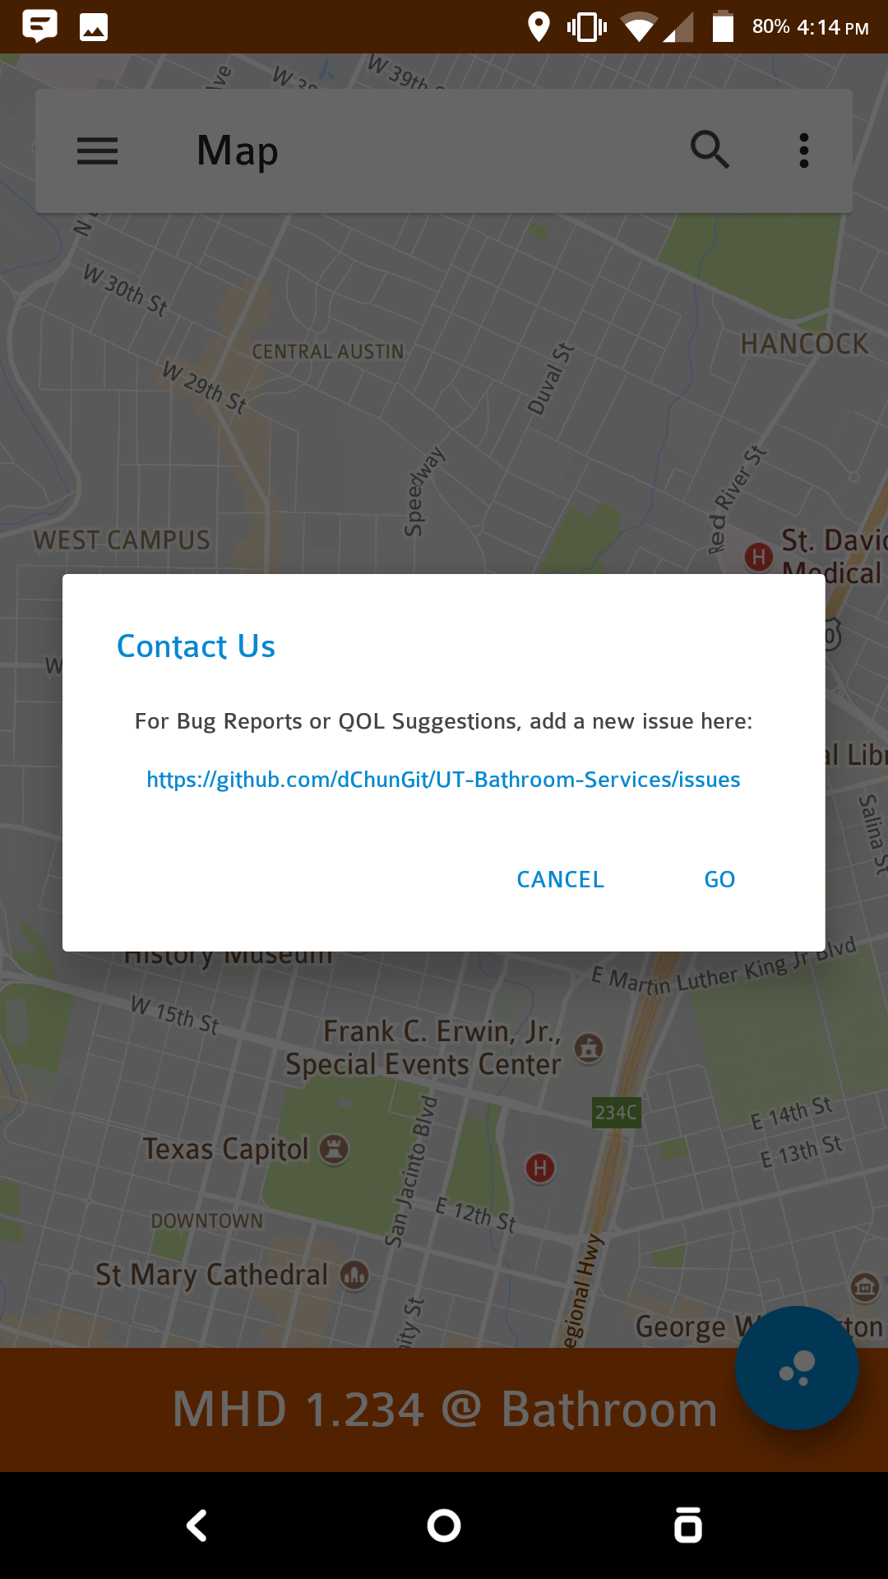

***Diagrams:***

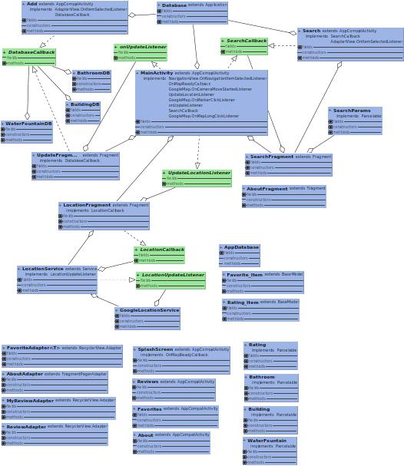

***Libraries and Licenses***

*Apache 2.0*

* FloatingActionButton: 1.6.4
* Calligraphy: 2.3.0
* Simple Rating Bar: 0.1.5
* AVLoadingIndicatorView: 2.1.3
* TapTargetView: 1.10.0
* Google AppCompat/Design Library: 27.0.1
* Google Play Library: 11.6.2
* Firebase Firestore 11.6.2

*MIT License*

* Material Dialogs: 0.9.5.0
* Scale Rating Bar: 1.3.2
* EasingInterpolator: 1.0.0
* DBFlow: 4.1.2

**Apache 2.0**

Licensed under the Apache License, Version 2.0 (the "License");  
you may not use this file except in compliance with the License.  
You may obtain a copy of the License at  
  
 http://www.apache.org/licenses/LICENSE-2.0  
  
Unless required by applicable law or agreed to in writing, software  
distributed under the License is distributed on an "AS IS" BASIS,  
WITHOUT WARRANTIES OR CONDITIONS OF ANY KIND, either express or implied.  
See the License for the specific language governing permissions and  
limitations under the License.

**The MIT License (MIT)**

Permission is hereby granted, free of charge, to any person obtaining a copy  
of this software and associated documentation files (the "Software"), to deal  
in the Software without restriction, including without limitation the rights  
to use, copy, modify, merge, publish, distribute, sublicense, and/or sell  
copies of the Software, and to permit persons to whom the Software is  
furnished to do so, subject to the following conditions:  
  
The above copyright notice and this permission notice shall be included in all  
copies or substantial portions of the Software.  
  
THE SOFTWARE IS PROVIDED "AS IS", WITHOUT WARRANTY OF ANY KIND, EXPRESS OR  
IMPLIED, INCLUDING BUT NOT LIMITED TO THE WARRANTIES OF MERCHANTABILITY,  
FITNESS FOR A PARTICULAR PURPOSE AND NONINFRINGEMENT. IN NO EVENT SHALL THE AUTHORS OR COPYRIGHT HOLDERS BE LIABLE FOR ANY CLAIM, DAMAGES OR OTHER LIABILITY, WHETHER IN AN ACTION OF CONTRACT, TORT OR OTHERWISE, ARISING FROM, OUT OF OR IN CONNECTION WITH THE SOFTWARE OR THE USE OR OTHER DEALINGS IN THE SOFTWARE.